|  |  |
| --- | --- |
| **Important Dates:**  3/11- End of the 3rd Nine Weeks  3/11- PBIS 3rd Nine Weeks PBIS Sidewalk Chalk Reward Celebration & Snack (390 points expected)  3/14- 3/18- Spring Break **(No School)**  3/21-Parent Engagement Opportunity  (Parents As Teachers- Time Management 6:00-  7:00 pm)  3/21- Fair Garden Re-Enrollment Packets Will  Be Sent Home With PK3 Students  3/25- Students’ 3rd Nine Weeks Performance Reports Are Sent Home  4/13- PK4 Cap & Gown and Group Pictures (Proof for cap & gown; prepay for groups)  4/12/2022- Knox County Schools **Kindergarten Round-Up** At All Knox County Schools  4/14- Fair Garden’s **PK Round-Up** (4:00-6:00 pm)  4/15- Good Friday **(No School)**  4/18- Holiday **(No School)**  4/25- Hearing Screenings Happen This Week At Fair Garden  5/2- Teacher Appreciation Week Begins  5/5- Last CRRAFT Family Night (6:00-7:00)  5/6- Fair Garden’s Mother Day Event  5/20- PK4 Stepping Up Program (More information to come)  5/25- Last Day For Students (**11:15 am Dismissal**)  A picture containing text, vector graphics  Description automatically generatedA picture containing text, vector graphics  Description automatically generatedA picture containing text, vector graphics  Description automatically generatedA picture containing text, vector graphics  Description automatically generated  images.jpegThe Guiding Light images.jpeg  Volume 3 Issue 7 <https://www.knoxschools.org/fairgarden> Published Monthly March 2022 | Screen%20Shot%202018-08-31%20at%2010.17.55%20AM.pngScreen%20Shot%202018-08-31%20at%2010.17.55%20AM.png    **A Note From Our Social Worker- Deanna Gnage**  **Fair Garden’s Focus on Social Skills**    It is so exciting to see your child beginning to formulate letters, numbers, and words!  But did you know that they are learning to master appropriate social skills along with the academics they are being taught?  Studies have shown that the most productive skills that your children will learn at the beginning of the year are social:  Empathy, Independence, Curiosity, Cooperation, Communication, Confidence, and Self-Regulation.  And when they learn social skills, it in turn helps them to settle in to better learn how to master the academic part of school.     A large number of parents returned my Parent Survey that I put out at the beginning of the school year.  You gave input on your top 3 choices of where your son/daughter may need social skill support during the school year.  Furthermore, over 53 parents requested that their son/daughter be part of a small group that focuses on learning specific social skills.  You know your son or daughter better than anyone and you were heard!     Ideally, your child learns social skills best in the context of the classroom through play.  Play is important work as this is how your daughter or son investigates the world and learns.  As he/she interacts with other children they are practicing sharing, negotiation, communication, and empathy.   The teachers and I have watched your children interact with one another for 3 months.  I have spoken to the teacher of each child whose parent requested specific help in different social areas and asked whether the child has mastered the skills noted by the parent in the classroom.    If he/she has, then they will continue to sharpen their social skills in the classroom throughout the rest of the school year.  However, if a teacher notes that a child is wrestling with a particular skill or emotional response, then I will be contacting you to discuss whether you think they would benefit from being in a group of 2-3 children who will practice a social skill with me.   Know that we value your insightfulness into what your child struggles and is successful with and how we can best teach your child.  It is amazing to see your children thrive and grow!  Thank you so much for working with us and communicating to us where YOU think your child needs to grow!  This doesn’t need to just happen at the beginning of the year  ----- please keep communicating with us and helping us to know.  Deanna Gnage, LMSW  Fair Garden School Social Worker  (865) 257-5826      **Please make sure to check our school-wide Dojo, your child’s class Dojo, and our school website to stay informed about events that are happening at Fair Garden.** Please join our electronic platform: **Fair Garden’s Twitter:** <https://twitter.com/fair_garden> **Thank you. ☺** |
| Positive Quote:    **Teacher Of The Month**  ** | large_651e2a4a-23cf-4813-b6fe-96cd6a51692e.jpg**A Message from Mrs. Spikes** large_651e2a4a-23cf-4813-b6fe-96cd6a51692e.jpg  We had several special visitors reading to our students to help us celebrate reading and promote the love of reading with our Fair Garden students for our Read Across America. We are thankful for the local celebrities that read to our Fair Garden students. Our Fair Garden students shined BRIGHTLY and were respectful to our guest readers. Their behavior was TOP notch and every visitor stated how well-behaved our students were, during the reading. We truly earned gold stars for our wonderful respectful behavior.  Thank you for reading with your child **at least 20 minutes every day** and reinforcing behavior expectations. It is vital for our students to be exposed to reading every chance they have during the day. Thank you for reading with your child at home. Thank you for being actively involved and engaged with your child’s education. Please ask your child’s teachers how you can help in their classroom. **We welcome and appreciate volunteers.** Teachers are always needing someone to make copies, send in treats for their classroom PBIS incentives, etc. We appreciate your partnership. Thank you for asking how you can help.  As the end of the school year is quickly approaching, we are working even harder to make sure our students are kindergarten ready. Students need appropriate behavior to learn and reach their optimum potential in school. Thank you for your support with your child’s behavior. It is not okay for students to hit other friends at school or staff. We expect our Fair Garden students to use their words and social-emotional strategies they’ve been taught when they are upset. **Below you will find the zones of regulation and calming strategies that you can use at home to help reinforce what we are doing at Fair Garden.**  Thank you,  Principal Spikes  Timeline  Description automatically generated  Graphical user interface, website  Description automatically generated with medium confidence |



**Clinic Reminders:**

* If your student has had fever (100.4 or greater), diarrhea, or vomiting, please keep him/her home until symptom free for 24 hours without the use of medication.
* If your student has multiple symptoms of Covid-19 (cough, difficulty breathing, fever, chills, congestion/runny nose, headache, nausea/vomiting, diarrhea, muscle aches, fatigue) please keep him/her home until symptoms have improved or you have a note from a healthcare provider regarding the symptoms.
* Thank you for helping to keep our students and staff healthy!

Sleep helps kids grow strong and healthy! Most preschool age children (3-5 years) need **between 10 and 13 hours of sleep over a 24-hour period** and usually one daytime nap.

Maintaining a **bedtime routine** can help your child have the best rest possible.

* Choose a consistent bedtime and wake-up time and stick with it.
* Begin your bedtime routine 30-60 minutes before time for lights out. Dim overhead lights and turn off screens (TVs, phones, tablets, computers, etc.). Offer water, milk, or a light snack; avoid caffeine or sugary items. Bathe and brush teeth. Change into comfortable pajamas. Some calming activities may include reading a book, singing songs, or listening to peaceful music. Many children are comforted by a stuffed animal or special blanket.
* Provide a sleep space that is quiet, cool, and dark. Some children sleep best with a dim night light.
* 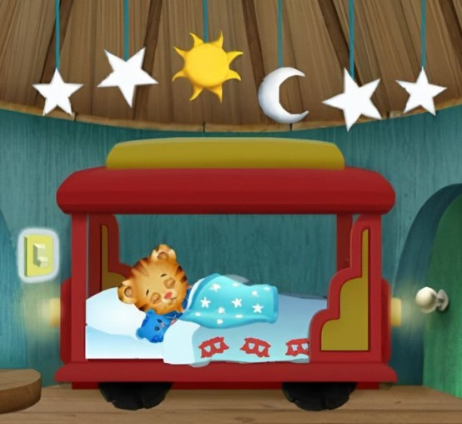Tuck your child in while he is sleepy, but still awake. This will help him learn to fall asleep on his own.

For more information, visit:

<https://www.pbs.org/parents/thrive/solving-sleep-problems-key-principles-for-helping-your-child-become-a-good-sleeper>

<https://my.clevelandclinic.org/health/articles/14302-sleep-in-toddlers--preschoolers>

**From the PTA:**

Thank you to everyone who brought food for the February Staff Appreciation Breakfast! We enjoy getting to show our appreciation for the staff that work so hard with our kiddos. Remember, this is a potluck-style breakfast on the last Friday of each month. If you would like to participate, we will be delivering breakfast on **3/25/22 at 8:15am**.  PTA officers will send out this month’s sign-up sheet the Friday before spring break, so be on the lookout!

Also, our next PTA meeting poll will be sent out this week to find the best day and time for everyone to attend. The link will be emailed out, and of course, if you aren’t on the PTA email list but want to be, please reach out to us at [fairgardenpta@gmail.com](mailto:fairgardenpta@gmail.com).

We have formed committees to start planning for all the great ideas that were shared at the last meeting. Each committee has a leader that will be contacting you to begin planning for each event. Thank you to all who have been working every step of the way to make these wonderful things happen!  — we are grateful for you!

Sincerely,

Thank you,

-Fair Garden PTA Officers, Allison Comer, PJ Hoskins, and Taurika Boateng

